Working prinicipal of a washing machine:

What is washing machine?

It is machine used to wash the cloths

Why it is used?

To reduce the human effort and time deficiency

Image of washing machine:

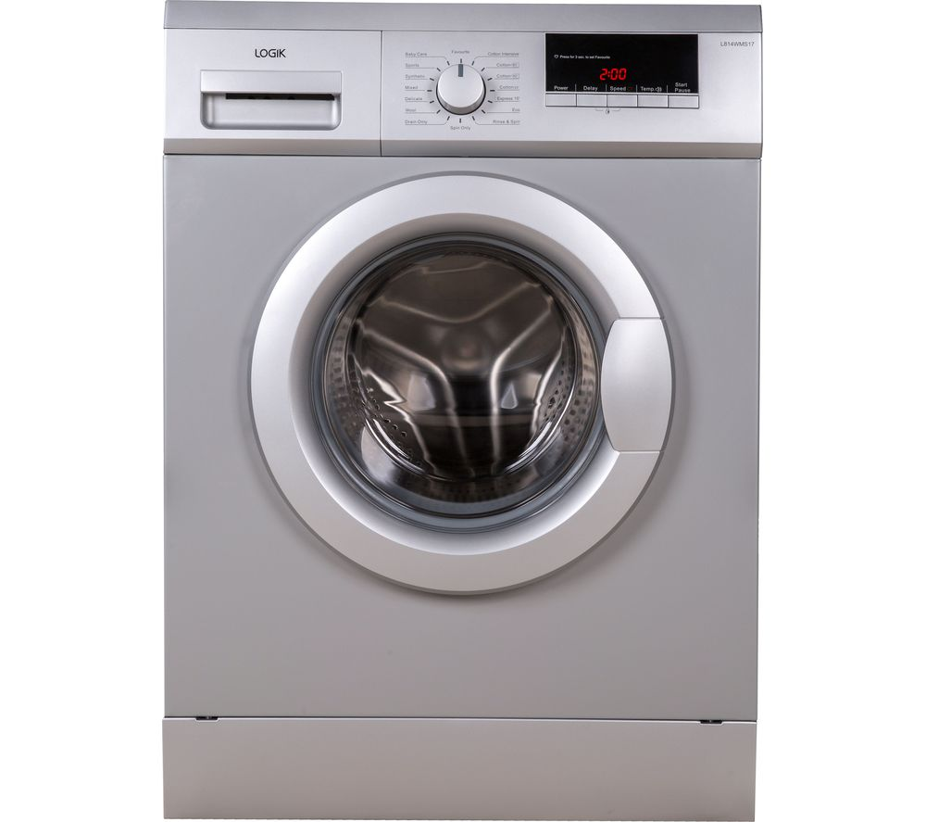

Components in washing machine:

Waging machine

Water in let & out let pipe

Timer

Quantity analyzer

Motor

Waging machine:

When we put cloths in machine it will automatically show that how time is requires to wash it and also how quantity of water and take and start and complete in time what it show’s on display

Water in let out & let pipe:

By the waging machine of cloths weight it takes water and wash and flesh the water out from the out let pipe when water is coming a tap it just gives the one buzzer sound and stop until the come’s and again start when water come’s

Timer:

It display that how much time to complete wash the cloths and also the quantity of water

Quantity analyzer:

It tell that how quantity of water is required to wash the cloths by taking and washing and flesh out the water from out let

Motor:

It is used to rotate the drum in washing machine

Block diagram:

Waging machine

Input

Micro

controller

Quantity analyzer

Water in let out let

Timer

motor

How it works:

First connect the water pump and switch when we on it after that put the cloths by the waging machine it show how much time requires and also quantity of water by taking and wash the cloths in time it will display’s .from the input it send the information to the micro controller to waging machine and to the out put motor is used to rotate the drum to wash the cloths